LAB 2

Q1. Write a method that takes two String arguments and uses all the boolean comparisons to compare the two Strings and print the results. For the == and != , also perform the equals() test. In main(), call your method with some different String objects.

public class Q1 {

    void compare(String String1,String String2){

        if(String1==String2)

        {

            System.out.println("Successful in ==");

        }

        if(String1.equals(String2))

        {

            System.out.print("Successful in equal function");

        }

        else if(String1!=String2)

        {

            System.out.print("Successful in !=" );

        }

        else

        {

            System.out.println("Unsuccessful Run");

        }

    }

    public static void main(String a[])

    {

        String String1="Ram";

        String String2="Ram";

        Q1 obj=new Q1();

        obj.compare(String1,String2);

    }

}

**Output :**

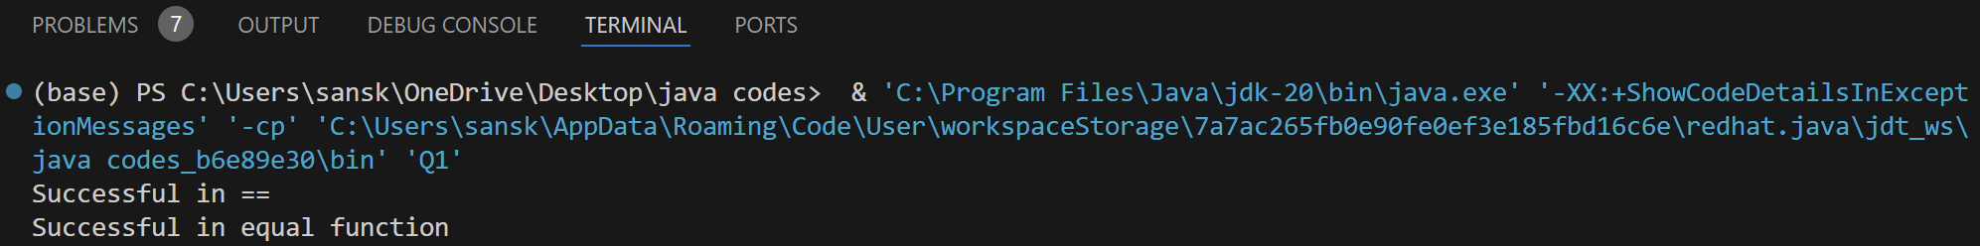

Q2. Create a class called Dog containing two Strings: name and says. In main(), create two dog objects with names "spot" (who says, "Ruff!") and "scruffy" (who says, "Wurf!"). Then display their names and what they say. Also create a new Dog reference and assign it to spot's object. Test for comparison using and equals() for all references.

public class Dog {

    String name;

    String says;

    void display()

    {

        System.out.println(name +" says "+ says);

    }

    public static void compare(Object String1,Object String2){

        if(String1==String2)

        {

            System.out.println("Successful in ==");

        }

        if(String1.equals(String2))

        {

            System.out.print("Successful in equal function");

        }

        else if(String1!=String2)

        {

            System.out.print("Successful in !=" );

        }

        else

        {

            System.out.println("Unsuccessful Run");

        }

    }

    public static void main(String a[])

    {

        Dog obj1=new Dog();

        Dog obj2=new Dog();

        obj1.name="Spot";

        obj2.name="Scruffy";

        obj1.says="Ruff";

        obj2.says="Wurf";

        obj1.display();

        obj2.display();

        Dog obj3 = new Dog();

        obj3=obj1;

        Dog.compare(obj1,obj3);

    }

}

**Output :**

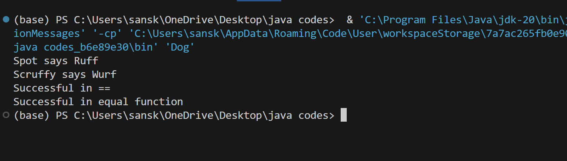

Q3. String comparison

class StringComparison {

    boolean compare(String String1,String String2){

        if(String1==String2)

        {

            return true;

        }

        return false;

    }

    public static void main(String a[])

    {

        String String1="Ram";

        String String2="Ram";

        StringComparison obj=new StringComparison();

        System.out.println(obj.compare(String1,String2));

    }

}

**Output :**

